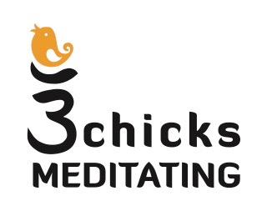
3 Chicks Meditating Retreat Registration

Today’s Date:

Retreat Dates: November 15-17, 2019. Check-in 4 pm. Check-out November 18, 10:00 am.

Name:

Address:

City: State: Zip:

Telephone: Email:

How did you hear about the retreat?

Health issues/medications, and any dietary needs?

Retreat fee per attendee is $888.00

Registering for weekend with a friend. Please apply $50.00 discount per attendee, when registration and payment received before July 1.

Cancellation policy: If you should have to cancel unexpectedly your payment is fully refundable less a 20% cancellation fee when cancellation is received in writing at least 7 days before the program start date. After that date, registration payment is non-refundable.

Email registration form to: 3chicksmeditating@gmail.com

Payment via PayPal to: https://www.paypal.me/svjohnson8817

A confirmation letter will be emailed to you upon receipt of payment.

